Name: Yeabsira Feleke

Roll:20222755

Differentiate between centralized and distributed computing using python by measuring execution time.

Code:

import time

def sum_of_squares(n):

    return sum(i * i for i in range(1, n + 1))

start_time = time.time()

result = sum_of_squares(10_000_000)

end_time = time.time()

print(f"Result: {result}")

print(f"Execution Time (Centralized): {end_time - start_time} seconds")

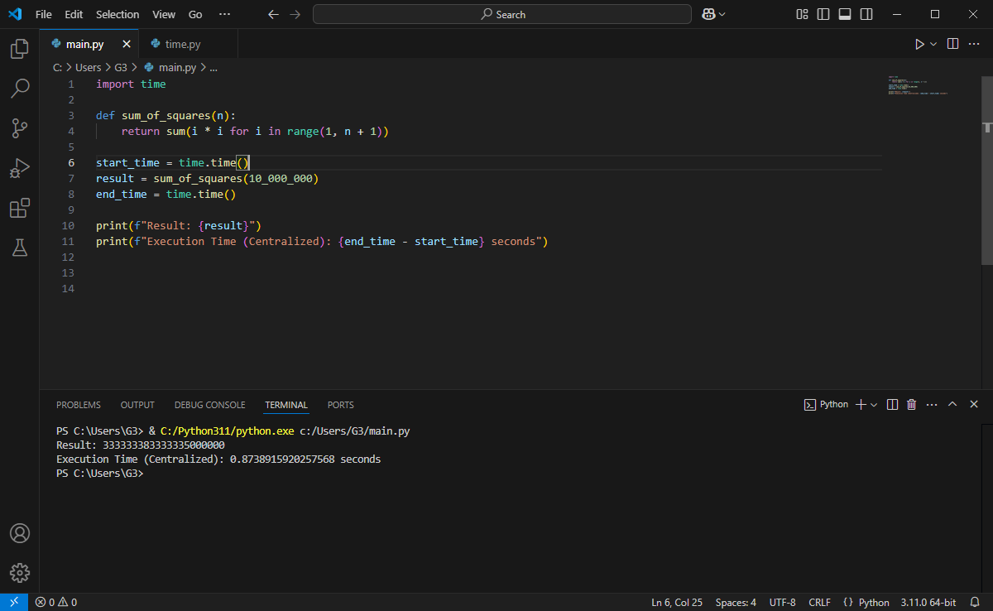***Result***

***Code:***

import concurrent.futures

import time

def sum_of_squares_range(start, end):

    return sum(i * i for i in range(start, end))

def process_range(r):

    return sum_of_squares_range(*r)

def distributed_sum_of_squares(n, num_workers=4):

    chunk_size = n // num_workers

    ranges = [(i * chunk_size + 1, (i + 1) * chunk_size + 1) for i in range(num_workers)]

    with concurrent.futures.ProcessPoolExecutor(max_workers=num_workers) as executor:

        results = executor.map(process_range, ranges)

    return sum(results)

if __name__ == '__main__':

    start_time = time.time()

    result = distributed_sum_of_squares(10_000_000)

    end_time = time.time()

    print(f"Result: {result}")

    print(f"Execution Time (Distributed): {end_time - start_time} seconds")

***Results:***

